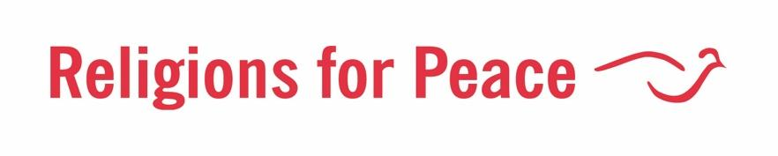
Regional Webinar on Global Multi-Religious Faith-in-Action Initiative Faith and Positive Change for Children, Families and Communities
Background on the Initiative
Faith and Positive Change for Children is a global partnership between UNICEF, the world’s largest inter-faith network Religions for Peace and knowledge partner JLI (Joint Learning Initiative on Local Faith Communities which begun in 2018 and was officially launched by RfP and UNICEF’s Executive Director in Washington DC in October 2019. The central aim of the partnership is to support positive social and behaviour change with and for children, parents and communities with specific emphasis on going beyond simply delivering messages, to engaging faith communities in self-reflection, dialogue, exchange and feedback in order to achieve real and lasting positive change on jointly agreed priorities affecting children and their families. In the context of the global COVID-19 pandemic, the FPCC partners have agreed to immediately shift focus of its joint work through a united Faith-in-Action campaign to respond to the crisis to provide more coordinated and evidence-based support for the protection and well-being of children and their communities. The initiative aims to mobilize Religious leaders, Women in Faith and Youth in Faith within RfP through its Inter-Faith Councils at country level to support COVID preparedness and response. The global campaign/initiative will promote and support 6 main actions:
- Development and release of national Inter-Faith/Faith messages by top-religious leaders to religious followers particularly around the holy days of Easter and Ramadan to customize and reinforce the inter-faith position statements from highest level religious leaders in support of the campaign.
- Collection of information and establishment of monitoring mechanisms to assess and track how religious institutions, beliefs, leaders, and practices are influencing positively and negatively in order to inform preparedness and response efforts and to more effectively address both the short term and long-term effects of the pandemic.
- Development, dissemination and local customization of Thematic Resource Guide to provide information, practical tips and religious teachings on specific topics to guide the United Faith-in-Action efforts in support of parents and communities to be used and customized by the religious leaders. Some initial areas of focus will include: Communication, misinformation, rumours; Dispelling fear, stigma, discrimination; Physical distancing, adaptations of religious gatherings and rituals, Handwashing and Hygiene; Support to specific vulnerable groups and to parents on preventing violence against Children and social solidarity.
- Periodic Regional webinars – to be coordinated by RFP and UNICEF HQ and Regional offices with interventions by selected religious leaders, Women of Faith and Youth in Faith and international experts coordinated country level United Faith-in-Action campaign to provide guidance, share good practice within the region and serve as a feedback mechanism.
- Digital and Mobile engagement to exchange information and engage communities and young people in support of the campaign in the context of physical distancing. This will include dissemination of mobile versions of messages from the campaign Package on UNICEF’s Internet of Good Things (IOGT) and leveraging of the U-Report platform by Faith Reporters and collection of information by these and other digital platforms to inform action.
- Tracking, monitoring and documentation of the results of the campaign through regular reports and case stories from communities to country IRC focal points and through the Global FPCC website linked to the global RfP website.

Coordination Structure for the Campaign The campaign will rely on the global Religions for Peace network. This comprises a World Council of senior religious leaders from all regions of the world; six regional inter-religious bodies and more than 90 national ones; and the Global Women of Faith Network and Global Interfaith Youth Network. On the side of Development partners, UNICEF will lead the coordination of campaign in close collaboration with WHO, IFRC, UNOHCR and other interested bodies. JLI in collaboration with UNICEF will coordinate the preparation of communication and mobilization package, drawing on inputs from UNICEF COVID materials for parents, youth and communities, RFP, and the Faith and COVID network JLI has established with Georgetown University. FPCC will also continue collaboration with its established Advisory Group of International FBOs including Islamic Relief Worldwide, Rissho Kosei-Kai, World Vision, Jewish World Service, Episcopal relief and Development, Tearfund, Salvation Army, ACT Alliance, ADRA. These and other FBOs will both be consulted and actively engaged in the design and implementation of the campaign.

Annex 1

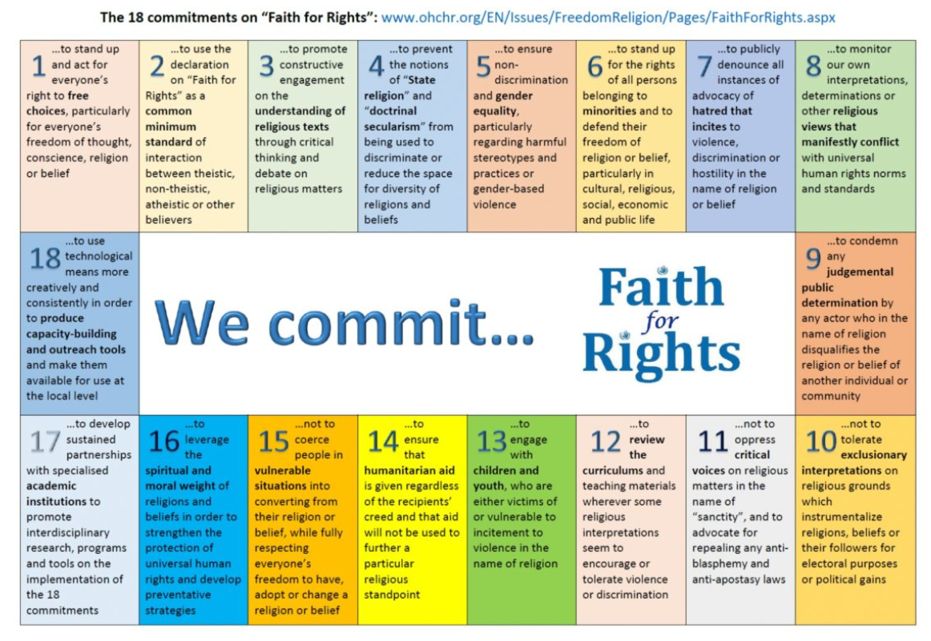

The Internet of Good Things (IOGT) is a mobile-ready website developed by UNICEF which increases access to development-focussed and life-saving information for marginalized populations. Based on the IOGT free-data partnerships with Facebook and national MNO providers, as well as its design specifically for feature phones (not only Smart phones), the platform is bridging the digital divide to reach vulnerable populations with access to educational and lifesaving information in 13 national and local languages. The current potential reach of IOGT is 32 million.
U-Report is an interactive SMS-based platform developed by UNICEF which engages more than 7 million adolescents, young people and community members across 60 countries in responding to polls and asking for and receiving tailored information. U-Report is a partner-led programme that works with over 350 distinct partners including governments, civil society, UN agencies, private sector, schools, universities and youth networks who engage to improve the impact of UNICEF and partner organisation’s programme results.

