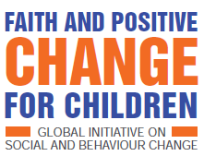

EARLY ADOPTERS’ WORKROCK
CAMEROON 2-6 DECEMBER 2019
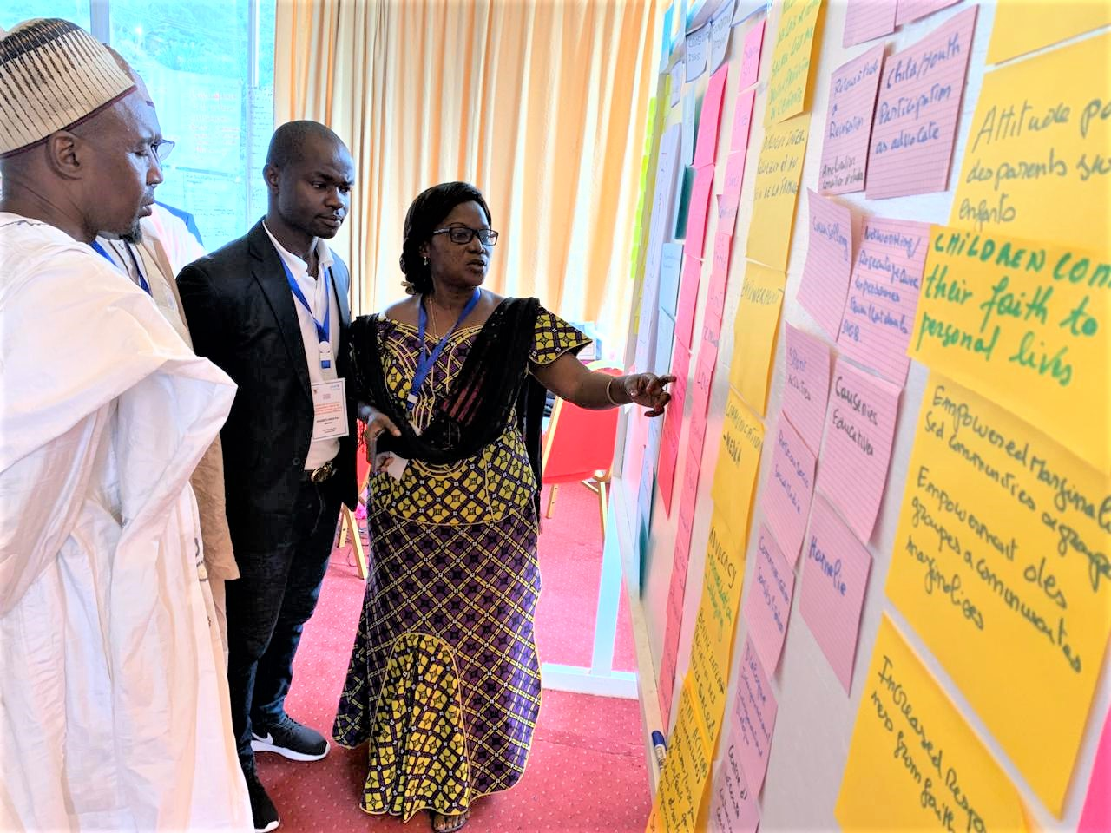
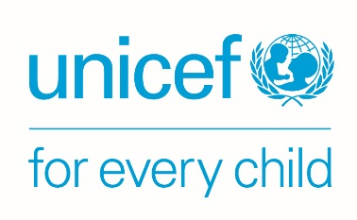
SUMMARY REPORT

WORKROCK PROCESS – FAITH FOR POSITIVE CHANGE FOR CHILDREN (FPCC)
Learning exercises combined with mind and heart dialogue/ breaking barriers activities to embed commitment

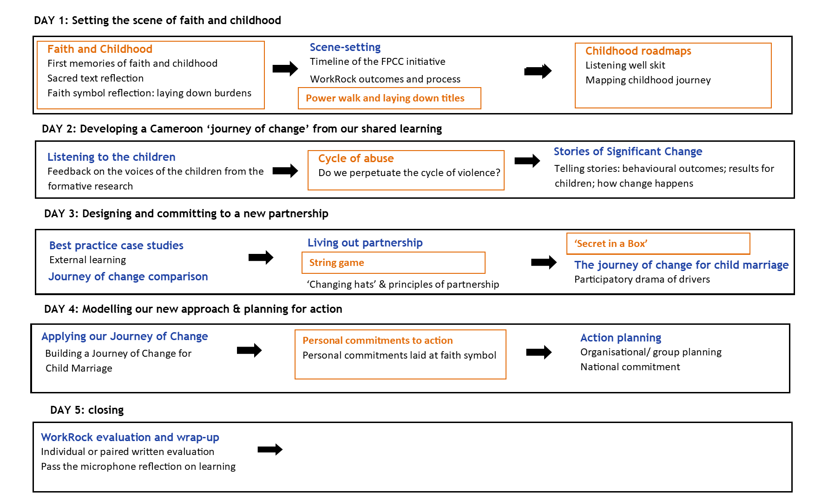
INTRODUCTION
The Faith for Positive Change for Children initiative
The ‘Faith for Positive Change for Children’ (FPCC) global initiative aims to build a new form of partnership between UNICEF and faith-based actors, enabling them to work together in a more effective, systemic, and scalable way to bring sustained impact in children’s lives. UNICEF has recognised the value of working with faith actors for many years, but its 2014 mapping showed that its approach across 150 countries was mainly ad-hoc, short-term and message-based, instrumentalising faith groups, rather than working collaboratively to address the complexity of social and behaviour change. In response, its Communications for Development (C4D) section teamed up with the ‘Joint Learning Initiative on Faith and Local Communities’ and ‘Religions for Peace’. In 2018, they drew together the global evidence base to show what really works, reviewed toolkits, held a UNICEF and faith partner workshop in Bangkok, documented case-studies of UNICEF’s existing work in this area, co-created a ‘Journey of Change’ for how faith actors and UNICEF can partner most effectively to impact children and set up an advisory group of 20 partner organisations and web platform to share resources.
The WorkRock purpose and approach
The initiative uses the term ‘WorkRock’ instead of ‘workshop’ to emphasise that these are not training to impart information, but learning together about the foundations of what creates lasting impact for children based on strong evidence and finding a new way of partnering. Three WorkRocks had already been held in South Sudan, Malawi and Liberia. All created their own Journey of Change from their experiences and learning, corroborating the global with the high degree of coherence. Cameroon’s WorkRock was attended by 50 UNICEF staff, government officials and different actors from the faith community. It aimed to achieve:
barriers broken down between and within faith actors and UNICEF
understanding and heart change in how to work
commitments to take forward the initiative
a shared vision for lasting, holistic & systemic change for children
(ownership of the initiative)

The WorkRock modelled a process of mind-heart dialogue using activities that did not just impart information but created space for deep self-reflection and discussion with others on personal experiences, beliefs and how these should impact our current practice. This fully participatory approach enabled particiapnts to build full ownership of their Journey of Change and for the WorkRock to impact them on the level of attitudes and beliefs, not just knowledge. Activities took place in a variety of group sizes, including: ongoing work in mixed groups; ‘buzz’ groups of three people for short brainstorms; and paired and individual work.
The WorkRock process
An opening ceremony launched the initiative in Cameroon with high level leaders from government, faith groups and UNICEF. The arrival of the Minister for the Promotion of Women and the Family opened the ceremony, which continued with a variety of speakers representing faith communities and the government. Many spoke of the challenges facing children and the role of faith groups in overcoming them, including 36% of girls being married before 19 and 22% of girls between 15 and 19 having already survived sexual violence.
“Child marriage is a violation of children’s fundamental rights. It is a danger for girls which limits their possibility of accessing education, affecting the finances of families and communities and perpetuating the cycle of poverty.”
(Minister)
It was noted that both the Bible and the Qur’an placed the child at the centre as all the faith leaders’ speeches called for an end to violence against children.
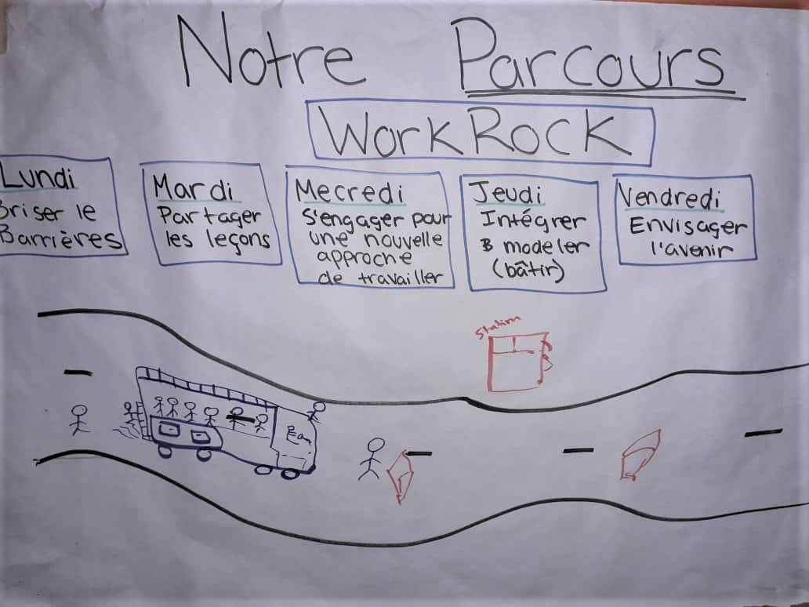
The WorkRock itself took place over five days. The detailed process is summarised above (p0) and in the WorkRock agenda (annex 2). Day 1 set the scene; day 2 used participants’ own learning and experience to build their Journey of Change; day 3 developed principles for partnership and a new way of working; day 4 applied the Journey of Change to a specific issue; and day 5 gave space for action planning. As it was important for participants to see how all the steps of the WorkRock could be applied to a specific issue that had already been identified by listening to children, although all activities were done generically (to create a Journey of Change that would work for every issue), they also collected ideas around child marriage to model how it would work.
- DAY 1: SETTING THE SCENE FOR FAITH AND CHILDHOOD
The first day focused on building an atmosphere of trust and enabling participants to reconnect with the mandate in their sacred scripture to protect children.
A1) Faith and childhood
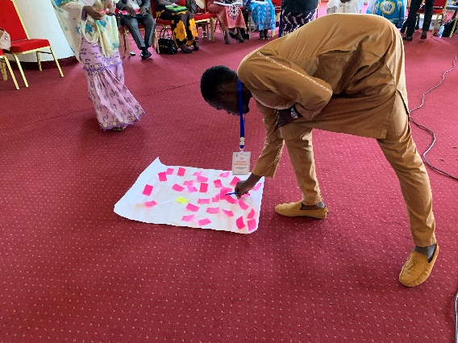
The WorkRock began with an ice-breaker to encourage participants to get to know one another. They then continued to build a sense of inter-faith community by reflecting on their earliest memories of faith. Several remembered how a traumatic experience had led them to faith or drawn them closer to God, such as illness, family death, violence or surviving a car crash. Some had undergone terrible experiences, such physical abuse, rape or abandonment. Many remembered a sense of comfort and safety from faith, though some young women were challenged to navigate gender norms. The activity drew participants together, creating a sense of solidarity through shared experiences and highlighting the significant role that faith can play in a child’s life.
Participants then discussed in inter-faith groups which stories from their sacred scripture were most relevant to how children should be treated. Noting that scriptures were sometimes used to justify violence, they rejected this and asserted a shared belief that love should never be a means to an end but an end in itself. Participants reflected on verses that showed they must care for and make time for children; that orphans were the responsibility of the whole community (Matthew 19:14; Qur’an Surah Al-Baqarah 2:233; Surah 4); that children have great value (Matthew 18:3); and that adults have the responsibility to show children what is right and give them good moral boundaries (Qur’an Surah Luqman 31:3-4; Proverbs 22: 6).
In a time of personal reflection, participants recalled their greatest regrets or any burdens they still felt in their life from these experiences. They wrote these out and laid them down to symbolise letting them go.
A2) Scene-setting and working together
Facilitators mapped the global timeline so everyone could see how the Cameroon WorkRock fitted and how every activity works together to build different sections of the ‘Journey of Change’, showing how to partner to effectively bring lasting change for children, with the underlying personal change through mind & heart dialogue.
“The best way to work is to listen to children and centre work on them.”
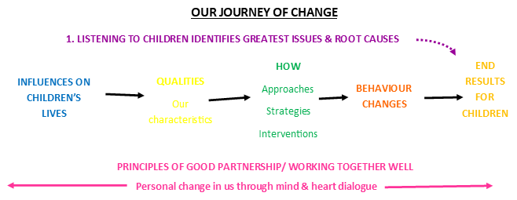
Participants shared concerns they had about the WorkRock, anything they were particularly looking forward to, or any reflections so far:
- “We’re the actors in this country and this is a reminder.”
- “We should continue to cultivate partnerships between men & women; Christians & Muslims; old & young.”
- “We must continue to work in the spirit of innovative collaboration and find new ways to work.”
- “No matter our religion…let that the protection of the child guide our partnership.”
- “I’m finding all of the WorkRock activities, like remembering our own childhood, to be critical.”
A3) Power Walk – leave no one behind
The ‘power walk’ activity challenged participants to reflect on different power dynamics within communities and within the WorkRock, identifying those vulnerable to being left out. Everyone was given a character and asked to empathise with their situation by stepping forwards when the facilitator read a statement that applied to them, such as ‘I can feed my family each day’ or ‘I can influence group decisions’. Participants noted that it was the most vulnerable, such as children and those living with disability, who were left behind, and that those with influence and power had a responsibility to leverage it to help children.
“If you have a heart for this work, to be in service of the children, you will always look ‘behind you’.” Participant
A4) Child roadmap – internalising our responsibility
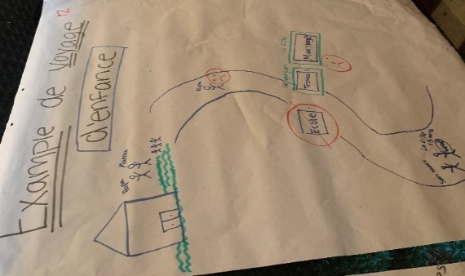
Listening skit: two volunteers performed a short drama to show the importance of really listening, with our head (to facts), our heart (to emotions, silences, body language) and our feet (to motivations, will). This paved the way for sharing more personal experiences.
Childhood map: To reflect on how their childhood experiences affected their treatment of children, participants drew a ‘childhood roadmap’ of significant highs and lows (example right). Then they found someone that they did not know and shared their story, discussing what had most helped and hindered them, including faith. Common helps were family members, education and the church; although family members could also be hindrances, as could events like war or struggles to find school fees. Participants reflected on how revisiting personal traumas can encourage us to help those in need; how a safe childhood can motivate us to provide the same to others without parents; and that education or the lack of it was one of the most significant factors in shaping the future.
- DAY 2: DEVELOPING A CAMEROON JOURNEY OF CHANGE
Before beginning, participants reviewed the first day. They described it as a very different from a usual workshop, very participatory and relaxed, without pressure. They appreciated that it was a space that recognised the role of religious actors and that they were reminded that they have the expertise to find the solutions, not wait for a solution from outside.
“When we came we thought that the solution should come from New York but with this WorkRock we understand that it must come from us.” Participant
During day 2, participants shared their knowledge and experience, strengthened with best practice case studies and other learning from the initiative, to develop a ‘journey of change’ that showed how faith groups can work with others most effectively to change attitudes and behaviour to bring lasting and positive results for children. Each of the activities contributed to building the Cameroon Journey of Change, and participants added the different elements to a wall chart as they went along. This built ownership as they could identify where all the sections came from.
B1) Listening to the children – how change happens and the influences
Participants then put on a hat to represent a boy or girl child and told stories that they had heard from children about the greatest challenges they face and the most influential decision-makers in their lives. One told a story about a 14-year-old girl with a two-year-old child who the participant asked how they had become such a young wife. She had never been asked before and was so grateful to be listened to and feel valued. Others told stories about young girls with HIV, a husband raping his wife, how social workers help in social reintegration and an Imam’s role in preventing child marriages.
Drivers/ root causes | Problems | Decision-makers/ influencers
- Lack of communication between parents & children  - Misinterpretation of scripture  - Lack of parental care/ neglect (broken families)  - Mental health issues – often ignored, leading to family violence, even to suicide  - Peer/ family pressure to early marriage – seeing it as a way to gain social rank  - Drug/ alcohol abuse  - Social media negatively influencing self-esteem  - Harmful gender norms  - Limited social services  - Community/ parents misconceptions about child marriage  - Covering up violence – taboo around sexual issues, stigma if you report  - Corruption of justice system – lack of justice for abuse  - External issues such as political crises and civil war | - Rape  - Inconsistent access to education (lack of funds; low value on girls’ education)  - Early pregnancy – traumatic, negative health consequences  - Child labour  - Orphans left to fend for themselves  - Forced/ early marriages as families do not have money to take care of them Not having birth certificate  - Trauma from violence | - Family (parents, aunts, uncles)  - Older respected men/ traditional leaders  - Medical officers/ staff  - Peer educators  - Neighbours who support in raising children  - Police  - Religious leaders  - Social workers/ counsellors  - Government officials  - Co-wives  - Communities  - Friends

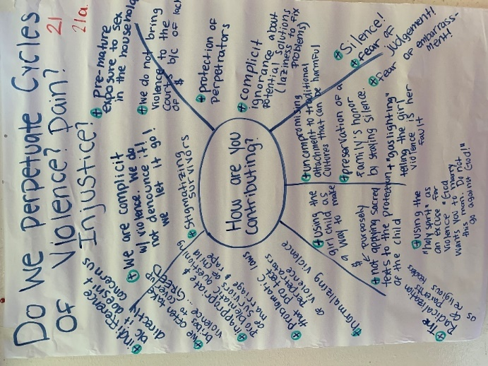
B2) Continuing the cycle of abuse
Participants explored their role in perpetuating cycles of violence. One significant way was by not speaking out, protecting perpetrators by not taking them to court. This was sometimes through fear of judgement, sometimes due to problematic laws and sometimes due to taking bribes to cover up violence. Survivors of rape often faced severe stigma, were subjected to inappropriate questioning or blamed for their own trauma. Another way that participants reflected that they contributed to violence against children was by misinterpreting scripture and so perpetuating negative cultural practices.
“We are complicit in violence. We do not denounce it, we let it go!” Participant
B3) Most significant change stories – developing our journey of change
Participants shared stories of where they had seen a connection between faith/ a faith group and lasting change in children’s lives. From these stories, participants worked in groups to identify needed changes in behaviours and attitudes that could positively impact children and overcome the negative drivers previously identified.
Behavioural & attitude changes | End results for children
- Better parenting: prioritising education; making time for children; reduced violence; reduced drinking  - Reporting violence & achieving justice for victims  - Faith leaders speaking out – in local languages  - Reduced family conflict | - Children speaking out, knowing their voices count, feeling supported by parents  - Confidence; self-belief  - Free from trauma  - Responsible citizens
They drew out how lasting change happened (or could have happened), through approaches, qualities of being and strategies, including:
- Creating space for dialogue and open communication - active listening with hearts
- Using sacred texts
- Humility
- Positivity, openness and willingness to learn
- Empathy
- Mobilising to work together
They also drew out who were the biggest influences on children’s lives:
- Parents/ parents in law  - Teachers  - Chiefs  - Neighbours | - NGOs  - Police  - Religious leaders  - Social workers | - Health workers/ nurses  - Extended family: aunts/ uncles  - Community child protection committees

C) DAY 3: DESIGNING & COMMITTING TO A NEW PARTNERSHIP
C1) Best practice case studies
Participants reflected on three case studies show-casing best practice in faith and positive change for children to extend their own experience. They drew out learning that interested them and that they thought could apply to their situation in Cameroon:
- Mobilising communities: development of the community by the community; everyone contributing what they have
- Seeking justice for victims: making sure everyone knows relevant laws; breaking silence with strong denunciations of perpetrators; using community courts
- Synergy: building unity through interreligious dialogue; partnerships between religious leaders, government, secular and faith-based NGOS
- Youth and children’s leadership/ participation: peer-peer dialogue; creating spaces for dialogue and fun for young people
C2) Comparing the Cameroon and the global Journeys of Change
Throughout the previous sessions, facilitators gathered the learning from the participants to create a wall chart that showed a ‘Journey of Change’: strategies and approaches that most effectively lead to the desired behaviour change outcomes and end results in children’s lives. Participants compared their Cameroon Journey of Change to the global one which was drawn together at a workshop involving over 100 UNICEF officers, faith-based and government partners from 20 countries following an extensive review of external evidence and best practice. They discussed similarities, differences, whether the global Journey of Change highlighted anything missing in their one or, conversely, whether any of their learning was missing from the global theory of change.

Family
Institutions
Policy
Systems
Individual
Community
They noted three key elements of the global Journey of Change that could strengthen their own:
- Foundational approaches: the idea that mobilising communities and mind-heart dialogue need to be integrated into every other approach
- Importance of mobilising all levels of influence: helpfulness to strategic thinking of dividing stakeholders into different levels that need to be engaged to protect children
- An enabling environment: the importance of external factors and the principles of the partnership itself in enabling change to happen.
They were also struck by the mechanism of reclaiming and reforming customs and traditions, removing harmful elements instead of seeing them as only harmful and needing to be stopped.
It prompted some interesting questions:
- How can we use it to create tangible results?
- How can we destigmatise victims of violence and reintegrate them into families and community?
- What are the priorities of children? What is their role in the struggle?
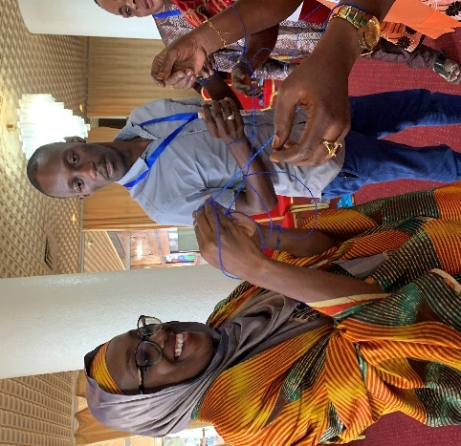
C3) Living out partnership
String game: Participants divided into pairs, each with a string tied around the wrists and threaded through their partner’s. They worked together to extricate themselves. When those who succeeded showed others how they had done it, participants reflected on the importance of genuine collaboration, struggling together to find a way out.
Changing hats: In their mixed groups, everyone took the role of a different stakeholder to empathise with them, identifying what they uniquely bring to the partnership (summarised below); and then what sort of partnership would enable them to best contribute their ideas and skills.

Partner | Role
Politicians | To create policies that prevent children being harmed; improve education facilities
Police | To enforce punishment on perpetrators, collaboration within force
Doctors | To create honest spaces to share information
Religious leaders | To collaborate, build inclusion and create space for dialogue – speak out strongly against violence/ child marriage; model good parenting
Chief | Judge GBV and build community mechanisms against it
Businesses | To facilitate communication and partnership between structures
Decision-makers (kings/ queens) | To create stronger controls to prevent child/ forced marriage
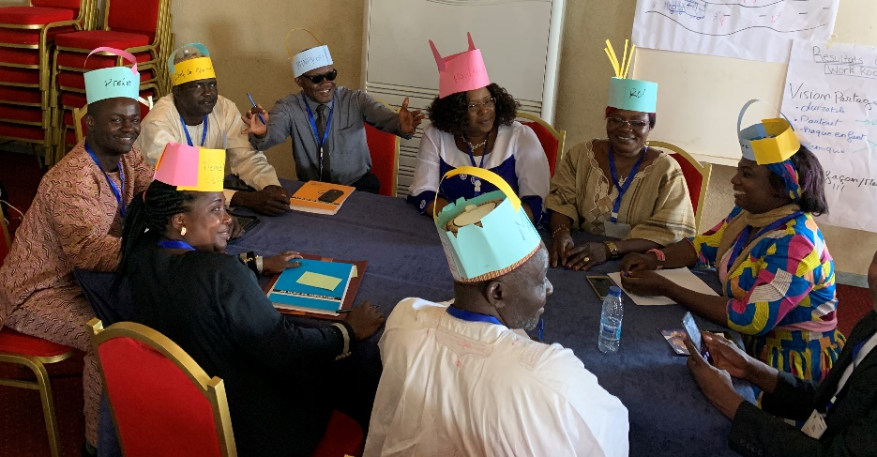
The groups then used a bean ranking technique to prioritise the most important principles. They each had beans to divide between the principles they had come up with, and move around until they agreed. These top principles included:
- Honestly / transparency
- Collaboration – working together
- Dialogue & communication
- Synergy
- Patient
- Humility
- Tolerance
- Altruism
- Listening to others
C4) Secret in a Box
To conclude the sessions on partnership, facilitators used the ‘Secret in a Box’ activity to highlight to explore who is the most important stakeholder in any partnership to protect children. They asked for three volunteers and handed the box to each of them in turn. The first guessed what objects were inside without opening it; the second closed their eyes and felt the objects; and the third could see and revealed the contents. Then the participants discussed who each might represent, considering the box as depth of knowledge of a community.
Participants decided that the first person represented NGOs and donors, without deep understanding of the community; the second, government, still with limited knowledge; and the third, community members and the children themselves.
They reflected how children and community are the experts on their own situations and that decisions cannot be taken without their participation. To protect children, a partnership between all three levels would be vital.
C4) Drivers of child marriage
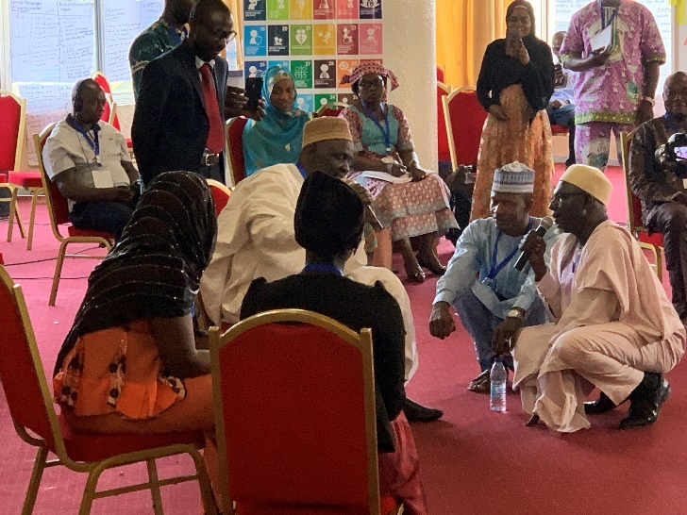
Next participants applied their Journey of Change to the issue of child marriage. Volunteers performed a drama showing some drivers of child marriage and their root causes. It showed an arranged marriage with the complicity of Imams and pastors, highlighting the role and motivation of each stakeholder in allowing the marriage to go ahead.
Drivers included:
- Economic situation: the parents lived in poverty and needed the money
- Social position: the marriage would raise the girl’s social status and quality of life
- Lack of value on girls’ education: the father did not think education was important for a daughter and he himself was illiterate
- Family power dynamics: the mother was unable to intervene
- Greed and corruption
- Misinterpretation of scripture: religious traditions were used to justify the marriage

Participants then discussed what could have happened differently to prevent this marriage:
- Educating parents and religious leaders about dangers to the girl’s health and laws
- Making space for the girl to express her views; guidance and support for her and her parents
- Mindset change in community – role of media in changing attitudes
- Seeking God’s will
- Engaging chiefs and community leaders
D) DAY 4: MODELLING OUR NEW APPROACH & PLANNING FOR ACTION
D1) Building a Journey of Change for Child marriage
Each group prioritised key drivers of child marriage, identified what behaviour change would overcome them and how they could be achieved. Some ideas are summarised below:

Drivers | How | Behaviour outcomes
Spiritual and moral poverty – not understanding why it is wrong  Harmful practices and cultural beliefs  Illiteracy  Lack of communication  Ignorance of civil laws/ legal provision  Misinterpretation of scripture  Stigma | Dialogue  Building capacity of religious leaders  Religious leaders conducting awareness – speaking out in sermons  Mothers & girls dialogue  Educating about laws; translating to local language  Reinterpreting scriptures  Involving youth in productive activities  Psychological support and reintegration for children  Creating new sources of income for families; capacity building; entrepreneurship skills  Lifeskills training  Family planning | Religious leaders taking action  Communities speaking out and reporting violence – creating committees to keep watch  Police taking action  Peaceful communities  Enforcing community laws - protective measures  Improved parenting  Good health practices
D2) Personal commitments
Everyone individually reflected again on sacred texts about protecting the rights of children and other vulnerable groups like widows. They then made a personal commitment to action, including:
- Working together as leaders from different religions to solve problems
- Using sacred scripture to raise awareness; denouncing harmful interpretations
- Supporting people to speak out
- Building an alliance based on a common commitment to protect children in sacred scriptures
- Promoting political support
- Demanding civil marriages before religious ones
- Speaking out about child protection in sermons
- Creating structures to protection children, especially to support orphans
- Playing a neutral role as mediator to promote advocacy
- Condemning all forms of violence as religious leaders
- Helping children to continue in education
- Sex-education for children
D2) Collective commitments
Participants also came up with ideas for pursuing the protection of the rights of children in their organisations or faith groups and for taking forward FPCC all together:
Ideas for faith groups | Ideas to ensure continued motivation/ follow up
- Joint advocacy to government  - Preaching sermons to raise awareness – helping people understand sacred scriptures  - Training parents and community  - Protecting orphans and widows; forbidding stealing goods  - Condemning all forms of discrimination against girls  - Refusing to celebrate child/ forced marriage – boycotting  - Protecting victims  - Being role models  - Building the capacity of religious leaders  - Dialogues with children and youth  - Campaigning with children  - Inter-religious cooperation and support  - Creating child protection committees | - Putting in place regional platforms to take forward FPCC/ bureau with major stakeholders to address child marriage/ network to struggle against violence  - Increasing visibility of issues & celebrate success: Facebook; media (radio, TV etc); sensitising at existing religious, cultural and sporting events  - WhatsApp group for participants to continue collaborating  - Strengthening existing platforms such as ACADIR
They decided to draft a collective commitment to be adopted at the closing ceremony.
E) DAY 5: CLOSING
E1) Collective commitment (Communique)
Participants reviewed the draft of the collective commitment and made suggestions for amendments to ensure it captured everything. The final version (Annex 5), adopted by all the religious leaders, noted the many forms of violence facing children, but particularly the dangers of child marriage. It also recognised the importance of the role of religious leaders in bringing positive change in people’s thinking and practices. They collectively engaged to put an end to:
- Forced and child marriage
- Using children in forced labour to make profit for parents/ teachers
- Consumption of alcohol or drugs by child
- Abuse in families of vulnerable children and orphans.
They adopted the slogan ‘Together we say no to violence against children and to child or forced marriage’ and engaged to collaborate together across religions and with the government, Religions for Peace and JLI.
E2) Closing ceremony
The Minister for the Promotion of Women and the Family returned to close the WorkRock and present certificates. She endorsed the work and the collective commitment made during the WorkRock, saying ‘Cameroon as a whole takes to heart the problem of youth, especially that of the girl!’
CONCLUSION
As the forth pilot country, the learning from Cameroon’s WorkRock will be key to taking this process forward. Each day, participants filled in a feedback form, sharing what worked well and what could be improved.
WorkRock outcomes
- Shared ownership of the initiative and a new way of working: 100% of the final evaluations ‘strongly agreed’ or ‘agreed’ that they had developed a new way of working together; 98% agreed that the WorkRock had met its aim, ‘to increase understanding of how to implement effective social and behaviour change approaches in partnership with other faith and development partners’; and 93% that the WorkRock had met their expectations, many of which were around understanding the initiative and their role within it.
- Barriers broken down between and within faith actors and UNICEF: 98% of participants ‘agreed’ or ‘strongly agreed’ that the WorkRock developed stronger collaboration amongst faith groups and 97% identified organisations with whom they planned to collaborate more closely, including UNCIEF, religious networks and government departments
- “Barriers were broken.”
- “From Day I found there were no barriers between Muslims and Christians because we all face the same challenges and want the best for our children.”
- “The atmosphere between participants is of a family.”
- “Everyone has let their barriers fall – priests, imams etc – and has become a simple participant.”
- Understanding mind and heart change in how we work: 100% of participants ‘agreed’ or ‘strongly agreed’ that the WorkRock activities and tools (many of which involve mind-heart dialogue) would strengthen their work; 92% said they were ‘quite’ or ‘very’ confident in facilitating mind-heart dialogue. Much of the feedback and commitments acknowledged the importance of engaging hearts as well as minds and creating space for dialogue, such as: “dialogue with children is very important in a family”.
- Ideas and plans to take forward the initiative: 98% of the evaluations ‘strongly agreed’ or ‘agreed’ that they had relevant plans to take action and 76% were ‘very confident’ that they could lead strategies to help end child marriage (95% including ‘quite confident’). Plans were creative and demonstrated deepened understanding of effective approaches. One participant commented: “I learned about going right to the ground level to face the facts as real as they are.” They also created a WhatsApp group to follow up one another and continue to share learning.
Learning
The feedback highlighted the following:
- WorkRock structure: Participants most valued the fully participatory nature of the WorkRock and how the Journey of Change was built up from their own knowledge. It came out top in the evaluations every day as the ‘most meaningful/useful’ element: “Unlike traditional symposia…this method allowed each participant to freely share their opinion and remain active throughout. The programme was not imposed. It created a platform for dialogue between religions, civil society and UNICEF.” However, some participants were not clear that the Journey of Change could be applied to every issue and thought that the aim of the WorkRock strategizing to end child marriage. Annex 3 demonstrates how the structure and aims of WorkRock can be clearly explained as building towards a new form of partnership, with child marriage as one possible application.
- Painful memories/ discussions: Participants highlighted how challenging they found some of the discussions: childhood memories, stories about the terrible abuse children survive and their own complicity in perpetuating cycles of violence. It would be good to have an appropriate man and a woman from each faith to volunteer to be around between and after sessions to listen and pray with participants.
- FPCC initiative: Some participants were unclear how this WorkRock was part of the global process and did not understand the comparison of the global Journey of Change to their own, although for those that did this was one of their favourite activities.
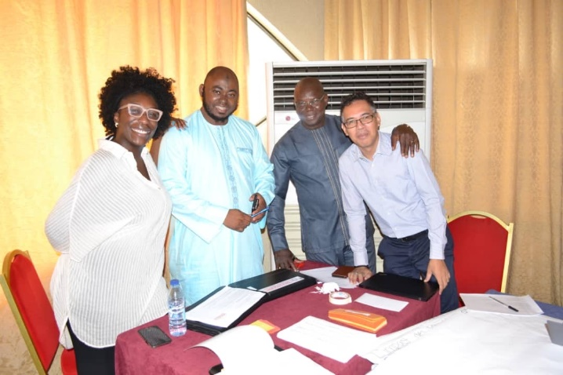
- Follow-up: The question of in-county follow-up remains important and unsettled. Participants may set up their own structures, such as the WhatsApp group, but from UNICEF’s side a balance needs to be found between ensuring participants retain full ownership, and providing continued encouragement and support.
- Facilitation: People described facilitation as ‘wonderful’ and many commented on the relaxed and friendly atmosphere. However, a few commented that not all facilitators seemed to know what was happening all the time. The facilitation team (right) concluded that, where possible, it is much easier for a facilitator if they have participated in a WorkRock first.
Summing up
Not only did participants come up with collective actions to take forward the FPCC initative in Cameroon, but made very honest personal commitments too, such as “some bad attitudes I have against my children, like violence, I but I couldn’t see this. Now I promise to never repeat it.” Not only did participants come to see how vital mind-heart dialogue is to create sustainable change for children, but were themselves changed by the mind-heart dialogue within the WorkRock.
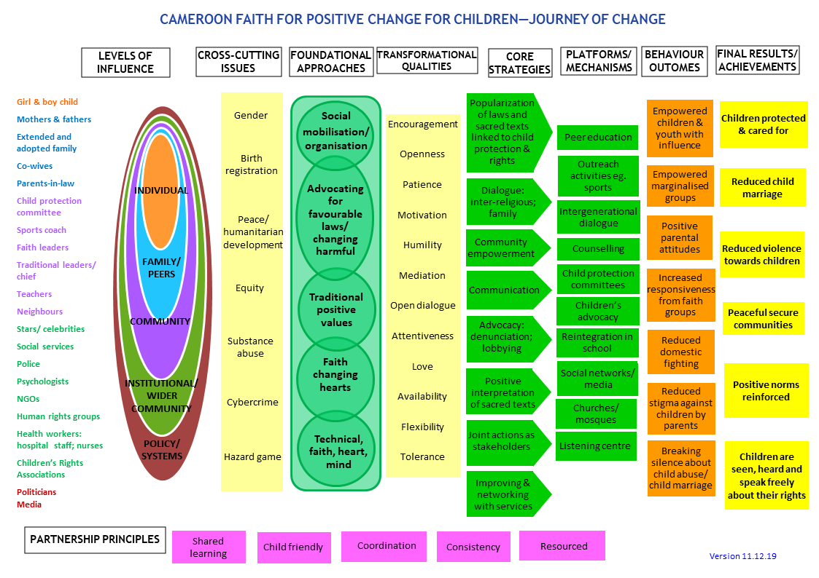
ANNEX 1: CAMEROON FPCC JOURNEY OF CHANGE

ANNEX 2: PLANNED WORKROCK AGENDA

Note: agenda differed in reality as timings shifted and facilitators remained flexible to the atmosphere amongst participants
DAY 1: BREAKING BARRIERS – ESTABLISHING TRUST AND SETTING THE SCENE

Time | Process
9.00 am | Objective: Open the WorkRock and set the tone for the week  High level launch: Welcome notes, shared the WorkRock vision and official launch
11.00am | BREAK
11.30am | Objective: A relaxed space for people to meet and begin to know each other  Arrival, registration and ice-breaker
11.45am | Objective: A shared faith/ ethics driven vision to protect and support children  Welcome: Framing the WorkRock; introducing facilitators; ‘who is in the room’ exercise  Faith and positive change for children:  - First memories of ‘faith and childhood’ – individual reflection  - Sacred text learning about our attitude and responsibility for children  - Faith symbol reflection: laying down burdens and biases  Introducing the FPCC Initiative  - Brief outline of initiative pre- and post-WorkRock
1.00pm | LUNCH
2.00pm | Objective: Set the scene for the WorkRock and created a safe space to contribute  Scene-setting – ‘Power walk, listening well and Childhood Roadmaps  - Check-in on outcomes and process for the WorkRock  - Faith symbol and reflection  - ‘Power walk’ activity to surface the barriers to participation  - Discussion of learning and laying down of roles  - Listening well: skit  - In peer pairs, draw childhood journey, mapping ups and downs, and analysing the role that faith and other internal and external factors played in helping and hindering  Wrap-up: housekeeping; mood meter; and explain evening brief task
5.30pm | CLOSE OF DAY
Evening | Case study preparation for activity next day in mixed groups of three

DAY 2: DEVELOPING CAMEROON JOURNEY OF CHANGE FROM SHARED LEARNING

8am | Arrival and registration for day
8.30am  9.00am | Objective: Shared learning about the impact of our FPCC work on children and society  Welcome and scene-setting for the day  - Check-in on guidelines for time together and process for the day – including groups and introducing journey of change template  Listening to the children  - Feedback on the voices of the children from the formative research
10.00am | BREAK
10.15am  11.00am | - Mixed group reflection on our role in stopping the cycle of violence  Objective: Shared learning about the impact of our FPCC work on children & wider society  Most Significant Change stories – behavioural outcomes and results for children  - Group sharing of Most Significant Change stories, documenting any lasting behavioural changes and results for children  - Group selection of one story of most sustainable and systemic impact
12.30pm | LUNCH – in mixed groups to choose a name for the group
1.30pm | Objective: Draw out the learning about what makes effective FPCC approaches  How we contribute most effectively to lasting and positive change  - Feedback selected story from some groups, analysing together what most helped to bring about and sustain the changes – write on post-its and cluster as each story is told.
3pm | BREAK
3.20pm  5.00pm | Objective: Surfaced hidden biases and internal/ external influences on change  Greatest influences on children’s lives  - Feedback selected story from remaining groups, analysing together what most helped to bring about and sustain the changes – and the influences that we need to address  - Influences – flipchart tool  Wrap-up: individual feedback on the day and housekeeping
5.20pm | CLOSE OF DAY
Evening | UNICEF team preparation of drivers of child marriage drama

DAY 3: DESIGNING & COMMITTING TO NEW PARTNERSHIP

Time | Process
8am | Arrival and registration for day
8.30am | Welcome and scene-setting for the day  - Welcome, recap, process for the day and check-in on guidelines for time together  - Personal story and faith symbol reflection  Learning from external best practice  - Case study group sharing in groups of three, drawing out learning from each case study and selecting three key points to share; plenary feedback of case study learning
10.30am | BREAK
11am | Objective: Adapted the FPCC Initiative theory of change, integrating WorkRock learning  Journey of Change reflection  - Balloon icebreaker: exercise on the importance of planning and working together  - Summary of the WorkRock learning and emerging Cameroon FPCC journey of change  - Global FPCC Initiative journey of change: brief check-in on how that looks  - Paired review: What is similar/ different? most important? missing or wrong?  Plenary feedback and refinement of the journey of change
12.30pm | LUNCH
1.30pm | Objective: Heart and mind understanding of a new way of partnering for systemic change  A new way of working together – living out partnership  - Individual reflection: Where have we have seen the best example of any partnership?  - Changing hats: double size mixed groups explore what kind of partnership and qualities would enable each actor in partnership for children to contribute effectively  - Ranking principles for partnership: Bean rank principles, discussing our roles
3pm | BREAK
3.20pm  5.00pm | Objective: Understood the drivers of child marriage and needed behavioural changes  - ‘Secret in a box’ activity – reflection on the roles each plays to work effectively  Participatory drama Modelling using Journey of Change in prioritised area  - Prepared group enacts participatory drama leading to plenary discussion of drivers  - Audience urged to consider alternative endings to the scenarios presented  - Plenary discussion of drivers and behavioural outcomes  Prioritisation of drivers  Wrap-up: Big Step review of the day; housekeeping; introduce resource documents.
5.30pm | CLOSE OF DAY
Evening | Review draft toolkit

DAY 4: MODELLING NEW APPROACH AND PLANNING FOR ACTION

Time | Process
8am | Arrival and registration for day
8.30am | Welcome and scene-setting for the day  - Welcome; pass the mic recap of the day; and process for the day  Objective: Developed a child marriage journey of change that reflects our different roles  - Planning together to tackle teenage pregnancy  - Buzz group reflection on formative research, stories and external learning about how to tackle child marriage that fits with our FPCC journey of change  - Place on journey of change chart approaches that are already working well and discuss what is missing/ what more needs to be done  - Mixed group development of a journey of change for child marriage, focusing on how to embed foundational approaches with strategies and different influences  Word café: Sharing of group journeys and what they find similar or different
10.00am | BREAK
10.30am | Commitment to take forward a new way of working together  - Exercise: Defenders balloon game  - Faith symbol reflection, leading to individual commitments: What one thing do I commit to take away from this week as an individual and follow up on with other faiths/ UNICEF  Objective: Understood in mind and heart how to work together to scale up change  Personal commitment  - Sacred text reflection about our own responsibility towards children, noticing where we may be blaming others rather than looking at what we are doing.  - Personal testimony (if possible)
12.00pm | LUNCH
1.00pm | Objective: Planned how we can take forward the learning in our own group/ organisation  Taking seriously what this means for our own faith group or organisation  - ‘Longest line’ activity to show the resources and strengths each brings to the group  - Bicycle plan: Peer group reflection on existing work that takes forward the learning from FPCC; what needs to be stopped/ reduced; and what we can do better or differently  - Agree ideas for how to use heart and mind and mobilisation activities to share learning within our group, work out what to do better and how to work with others  - Plenary feedback
3pm | BREAK
3.30pm | Objective: Plan how we can work together differently in our local areas and nationally  Planning for a new way of working together  - Share and compile ideas in national action plan  Wrap-up and closing
5.30pm | CLOSE OF DAY

DAY 5: CLOSING

Time | Process
8am | Arrival and registration for day
8.30am | Welcome and scene-setting for the day  - Welcome; pass the mic recap of the day; and process for the day  Objective: Shared learning and inspired each other to take forward learning together  Closing circle  - Pass the mic reflection: what one thing will stay with me from the week; one commitment I will take forward
10.00am | BREAK
10.30am | Discussion and adoption of closing commitment
12.00pm | LUNCH
1.00pm | Discussion and adoption of closing commitment
3pm | BREAK
3.30pm | Closing ceremony – presentation of certificates
5.30pm | CLOSE OF WORKROCK

ANNEX 3: HOW THE ACTIVITIES BUILD THE JOURNEY OF CHANGE

This overview shows how each activity builds ‘Our Journey of Change’ – how to partner effectively to bring lasting change for children – from participants’ own learning and external best practice. The order is slightly different from the previous page to highlight that your ‘Journey of Change’ can develop in different ways and in a different order (always underpinned by personal change through mind and heart dialogue). WorkRock activities are colour coded to show how they contribute to the journey of change:
OUR JOURNEY OF CHANGE

1. Listening to children IDENTIFIED GREATEST ISSUES & THEIR ROOT CAUSES

INFLUENCES ON children’S LIVES — helps & hindrances
Qualities — we need to show as faith groups
HOW — approaches, strategies, interventions
BEHAVIOUR OUTCOMES — changes in attitude & behaviour
END RESULTS FOR CHILDREN
PRINCIPLES OF GOOD PARTNERSHIP
— working together well
MIND AND HEART DIALOGUE—bringing personal change in us and others

C1. Connecting with Faith & Childhood
C2. Power Walk
C3. Listening Well
C4 Childhood Roadmap
C4.3 Listening to the children– feeding back from preliminary research to identify some of the greatest challenges children face and their root causes (drivers)
D1.1 Most Significant Change Stories: behavioural outcomes & end results for children - using stories about when we have seen the most long-term impact for children’s lives connected to faith groups to identify desired end results for children & needed behaviour change
D1.2 Most Significant Change Stories: How we contribute most effectively to lasting and positive change (including qualities) - how faith groups worked to bring these behaviour changes about
C7. Secret in a box
D2. Case study learning: how (including qualities) - what others have found to be most effective
D3. Flipchart tool: influences on children’s lives
C5. Balloon game
D4. A new way of working together – living out partnership
The rest of a WorkRock involves applying our Journey of Change to a specific example (such as child marriage) and action planning.

ANNEX 4: SACRED TEXTS ABOUT OUR RESPONSIBILITY TO CHILDREN
(Feedback from WorkRock participants and Sacred Texts quoted)

- We must care for and make time for children:
- “Jesus said, “Let the little children come to me, and do not hinder them, for the kingdom of heaven belongs to such as these.” (Matthew 19:14)
- Surah 4 – we all have responsibilities towards orphans, to care for them and protect them
- “Mothers may breastfeed their children two complete years for whoever wishes to complete the nursing [period]. Upon the father is the mothers' provision and their clothing according to what is acceptable.” (Qur’an Surah Al-Baqarah 2:233)
- “The second is this: ‘Love your neighbour as yourself.’ There is no commandment greater than these.” (Mark 12:31)
- Children have great value:
- “And he said: “Truly I tell you, unless you change and become like little children, you will never enter the kingdom of heaven.” (Matthew 18:3)
- We have a responsibility to show our children what is right, to bring them up in prayer and worship:
- “a guidance and mercy for the doers of good, who establish Prayer and pay Zakah, and have firm faith in the Hereafter.” (Qur’an Surah Luqman 31:3-4)
- “Start children off on the way they should go, and even when they are old they will not turn from it.” (Proverbs 22: 6)
- “Children, obey your parents in the Lord, for this is right.” (Ephesians 6:1)
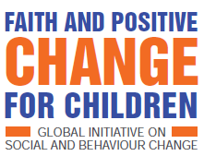
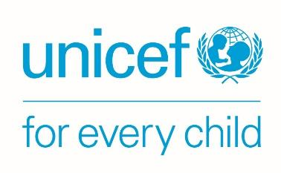
ANNEX 5: COMMUNIQUE

COMMUNIQUÉ FINAL ET ENGAGEMENT COLLECTIF DES LEADERS RELIGIEUX AYANT PRIS PART AU WORKROCK SUR LA « FOI POUR LE CHANGEMENT POSITIF EN FAVEUR DES ENFANTS : METTRE FIN AU MARIAGE D’ENFANTS AU CAMEROUN », TENU À YAOUNDÉ DU 25 AU 27 JUILLET 2019

Du 02 au 06 décembre 2019, nous avons pris part au workrock sur la « FOI POUR LE CHANGEMENT POSITIF EN FAVEUR DES ENFANTS : METTRE FIN AU MARIAGE D’ENFANTS AU CAMEROUN », organisé par le Ministère de la Promotion de la Femme et de la Famille, UNICEF, Religion for Peace, et Joint Learning Initiative on Faith and Local Communities à l’Hôtel Mont-Febe à Yaoundé. Au total près de 50 participants ont été mobilisé au sein des communautés religieuses (musulmans et chrétiens) et acteurs de la société civile œuvrant dans la protection des droits des enfants. La cérémonie d’ouverture était présidée conjointement par et Madame le Ministre de la Promotion de la Femme et de la Famille. Le représentant a de l’UNICEF a rappelé dans son discours d’ouverture l’objectif général de l’UNICEF, qui est l’amélioration des conditions des vies des enfants dans le monde. Il a rappelé une fois de plus le rôle du religieux dans le changement le processus de changement social. Madame le Ministre nous a rappelé les conventions de l’Union Africaine d’Addis-Abeba et d’Accra au Ghana pour mettre en place les mécanismes de lutte contre les violences faites et le respect de leurs droits.
Contrairement aux forums dans des styles très classiques et de modèles basiques, celui pour la foi pour le changement positif en vue de mettre fin aux violences subies par les enfants et au mariage d’enfants au Cameroun est plutôt un Workrock sorti des sentiers battus. Une méthodologie de travail qui aurait permis à chaque participant de donner pleinement son avis et être productif durant tout le forum. Il s’est agi d’une plateforme de communication interreligieuse, d’échanges entre les acteurs de la société civile et les facilitateurs des organisations internationales et du MINPROFF. Un esprit de partage et de convivialité qui a brisé les barrières ainsi que les clivages sociaux et religieux, on s’en félicite.
Cette initiative inclusive qui a impliqué les imams, les pasteurs, les prêtres, les prédicateurs et prédicatrices ainsi que les savants musulmans et chrétiens a permis l’identification des différentes violences dont font face les enfants au sein de nos communautés. Nous avons ensemble réfléchi sur les solutions et les actions conjointes à mener pour mettre fin à ces violences et plus particulièrement au mariage d’enfants au Cameroun. L’ensemble des activités, des réflexions et des échanges d’expériences de terrain dans les groupes ont permis de mettre en évidence des pratiques néfastes au sein de nos communautés qui affectent négativement la vie quotidienne des filles et des garçons dont nous avons la charge d’élever. Nous relevons que les normes sociales néfastes auxquelles ces jeunes enfants sont confrontés dans leur épanouissement personnel et social sont innombrables.
Au sortir de ce forum, nous notons tous et toutes que le mariage d’enfants et forcés dans les régions du Cameroun demeure une triste réalité et constitue une violation grave des droits fondamentaux de cette catégorie sociale. Cette pratique constitue un véritable danger pour la société, en ce sens qu’ils freinent le développement harmonieux des adolescentes, limitent leurs possibilités d’accéder à l’éducation, affectent l’économie et stabilité des familles et des communautés favorisant ainsi le cycle de pauvreté entre générations. »
Nous reconnaissons également que nous sommes des autorités religieuses et morale devant un joué un rôle capital dans le changement positif des mentalités et pratiques néfastes qui mettent en mal l’épanouissement des enfants. Plusieurs causes ont été identifiées dont les principales sont :
- L’ignorance des prescriptions religieuses et les lois relatives à la protection de l’enfant ;
- La pauvreté et la cupidité des parents ;
- La transformation inconsciente des pratiques traditionnelles néfastes en normes sociales ;
- Le manque de collaboration entre les différents acteurs travaillant sur la protection de l’enfant ;
- l’analphabétisme de certains parents ;
- le manque d’alternatives économiques pour les filles;
- la non application des textes juridiques et l’absence de sanction;
- la faible harmonisation des textes nationaux et ceux ratifiés au niveau international ;

Au vue de l’ampleur des mariages d’enfants et du mal que cette pratique cause à la jeunesse et à la société, nous avons compris que nous, leaders religieux sommes des acteurs stratégiques dans l’adoption et la promotion des valeurs et comportements basés sur la foi favorisant un changement positif en faveur des enfants. De ce fait, nous nous engageons collectivement à œuvrer pour mettre fin :
- Au mariage d’enfants et forcés au sein de nos communautés ;
- À L’utilisation des enfants pour le commerce et la mendicité au profit des parents ou de leurs tuteurs ;
- À la consommation des stupéfiants ou drogue par les enfants et aux violences familiales sur les enfants vulnérables et les orphelins ;
Notre slogan sera désormais : « ensemble disons non aux violences faites aux enfants et au mariage d’enfants et forcés ». Une mission qui nous exige une parfaite communication et collaboration entre nous ainsi qu’avec les autres acteurs engagés dans ce changement positif en faveur des enfants.
Nous appelons à l’engagement de tous les leaders religieux et traditionnel et à une synergie d’action entre les différents acteurs pour la protection des droits des enfants et l’abandon des mariages d’enfants au Cameroun. Nous restons disponibles et prêts à œuvrer au sein une plate-forme collective regroupant toutes les communautés religieuses pour mettre fin aux violences faites aux enfants notamment le mariage d’enfant et forcé. Nous nous engageons à collaborer et à accompagner le Gouvernement camerounais, Religion for Peace et Joint Learning Initiative on Faith and Local Communities, dans cette quête permanente du changement positif en faveur des enfants.
Fait à Yaoundé le 06 décembre 2019
ANNEX 6: PARTICIPANT LIST

NAME | GROUP/ ORGANISATION | ROLE
Ilyassa Adamaou | CSI | Member
Djafarou Marafat | CSI | Imam Garoua
Inna Rougayatou | CSI | Women’s affairs
Gambo épse Mbapeh  Rekeatou Lantana | CSI | ACADIR
Muhammadu Abubakar (Buea) | CSI | Imam Buea
Ibrahim Adamou | CSI | Responsible ACADIR
Fadimatou Gali | CSI | Social Affairs Yaoundé
Mouhamadou Nazir | CSI | Responsible for youth
Modibo Halidou | CSI | Imam Yaoundé
Nsangou Mama Awoulou Sine (Fban) | Union Of African Scholars | Member representative of Cameroon
Inna Adama Yaro Garba (Maroua) | CIDIMUC | Responsible for social affairs/ CAMWA region president
Zara Oumar | CIDIMUC | Responsible for centre for orphans in Garoua
Dr Fabilou (Ngdere) | CIDIMUC | Imam Ngaounderé
Aboubakar Mewada VII Moussa | CIDIMUC | Youth centre
Paraiso ISMAEL  GILDAS MARCEL | CIDIMUC | Responsible for communication with Imams (Douala)
Cheikh Ndanladi Ismael | CIDIMUC | Imam-Prédicateur
Père Joseph Edmond NYAM | ACADIR
Mme Françoise DOUDOU | Archdiocese of Garoua | Responsible for women’s programmes
Père Paul ADAMOU | Archdiocese of Douala | Responsible for welcome centres for vulnerable children
Soeur Berthe Florence MEDZA | ACADIR | Responsible for women’s projects
Ab Emérancien NDJAKOMO | ACADIR Ebolowa | Branch president, southern region
Père Serge ZINGA ZE | ACADIR
Fr. Ernest Mungu Epan | Diocese of Buea | Diocesan Youth Chaplain
Père Mathias | Diocese of Bafoussam | Curé de Paroisse
Mme Laura Anyola Tufon | Diocese of Bamenda | Coordinator for Justice & Peace
Mr Achille BOUBA SILA | Paroisse Bétare-Oya | Responsible for parish youth
Rev. EBAI Gustav TABI | Protestant
Rev. BOUM Basile | Protestant
Rev. HAMADINA Salomon | Protestant
Rev. AGBOR Jacob BATE 2 | Protestant
Rev. PINGPOH Margaret | Protestante
Rev. Aminou Bitang | Protestant
Rev. Dr. Jeanette ADA MAINA | Protestante
Pastor Nelson DJOBARA | Protestant
Mr. NGAZBI Te DIGUI Paul | Protestant
Mme YEPELE Therese | Protestant
Alexander Gwanvalla | GNCRC
APAH Erica Bangi | GNCRC
Dr Ana Gutierez | Catholic health centre | Director
AMINA Suzanne | ADRA | Responsible for education
Yougang Tame Henriette | OFIF | Responsible for vulnerable girls’ centre
Djondang Damarice | Femmes notables Ngaoundere | President
Aminatou Mourbare Rachel | ALDEPA | Technical director
Noubissie Epse Kuete Marguerite Ariane | Belle etoile Garoua | President
Ahmad Adjarou | Ligue des cadres musulmans | Regional Representative
Rev. Nkwenti Joseph Ndeh | Presbyterian Church in Cameroon | National Sunday School Officer
DIBO ELANGO Estelle BEDIE | Mothers’ Union | President
EKOUNDA NGORBO Ingrid | Association Musulmane pour l’Aide Humanitaire | President
Aissa Doumara Ngatansou | ALVF | President
OBELE ODOUH Felicite Yasmine | New Moslem Center for Charity (NMCC) | President

